ECEN 5053-002 Developing the Industrial Internet of Things

Product Teardown

**Samsung’s SmartThings Smart Home Hub**

by

Ayush Dhoot

14th April 2019

**Introduction:**

Samsung’s SmartThings Smart Home Hub is a smart home device that connects all the other devices present at home and makes them work simultaneously. It’s like a brain of the smart home and connects all the devices wirelessly. It helps controlling and monitoring all the devices present at home. You will need a SmartThings Hub or a compatible device that works well with SmartThings Hub for it function properly. [1] To use a SmartThings Smart Hub we must have the free SmartThings App for Android or iPhone and some connected devices. You can connect hundreds of individual devices at any one time to a SmartThings Hub, so you don’t really have to worry about having too many smart home devices at home. SmartThings was launched in the UK in 2015 and after multiple customer reports, various changes and advances were made to ensure compatibility of the device with various smart devices and smart apps. The main idea was to create an experience that makes living simple, accessible and intelligent. It is an open platform for consumers to bring all their smart devices together which makes their life simple and not complicated. There is no specific place to keep this device, it can be placed anywhere at home and all the devices can be controlled.

You can add as many additional SmartThings sensors or other popular Z-Wave, ZigBee, or Internet-connected products to enhance your connected home. It requires an internet-connected Wi-Fi router plus the free SmartThings app for Android (6.0 or later) or iOS (11.0 or later). Connected devices sold separately. It works in the US and Canada. There are multiple sensors that are used in this device which helps in putting the customer in control of the things he/she wants to monitor at home. The sensors used are motion sensor, water leak sensor, the button. You can also have full control over the SmartApp with allowing editing, adding or removing the configuration of the Hub. You have full control of the configuration, including editing, adding, removing, and even creating SmartApps. To create, you write code within the IDE for SmartApps and Device Handlers. SmartThings also has an integrated Simulator that allows you to simulate any devices even when they are not connected to the Hub.

**Problem Solved by the Device:**

The problem of controlling the house using a single application is solved using the Samsung SmartThings Smart Hub. The Hub acts as the centralized node which connects all the smart gadgets and appliances present in the house. All the gadgets may not be using the same network protocol so interfacing them individually might be a hassle to the user. In such cases, we require a hub which supports all of these networking protocols like Wi-Fi, Zigbee, Bluetooth among others. The device acts

as that hub which communicates between the gadgets having different protocols. There is a single application which can be used by the user to control all of the internet-connected and smart appliances which reduces the hassle of using different apps for different devices. They are easy to use as it has a simple UI and supports voice commands. The Smart Hub also has additional functionality which allows it to be used along with third-party applications like IFTTT applets, etc. Moreover,  with the Hub, we receive alerts and messages if something unexpected happens at home. If there’s a gas leak or an intrusion, the user will automatically be notified. You’ll also be notified if you’ve left appliances like iron, hair straighteners or oven accidently on. [2] With just one tap, you can arm your security alarm, lock the doors, turn off the TV and lights, activate motion sensors and link them to your security camera to start recording, change the temperature, and have a peaceful sleep knowing SmartThings is protecting your home.

**Device Market and Application Area:**

The Samsung SmartThings Smart Hub is primarily a device which is used mainly in home automation systems. It can also be used in other systems like monitoring a child, smart home, controlling an environment. [3] We can use the hub to do some of the following tasks:

* Set connected lights and switches from various sources to turn on and off when you open doors, change brightness at the right moment.
* Set connected cameras and doorbells to send you video notifications, turn on connected lights when there’s a visitor.
* Set connected door locks to open when you arrive home, lock when you leave the house.
* Set connected thermostats to turn on when you open the front door, turn off when you leave home.
* Set sensors and detectors to properly have a functionality of the house.
* Set real-time text and email alerts on the app so that the user receives the information.
* Set digital personal assistant integration.

The main application area of this device includes :

* Home automation- It uses a combination of hardware and software technologies that enable control and management over appliances and devices within a home. This device helps set up Smart lights to turn on/off on schedule, program your thermostat for energy efficiency, automate all your electronics, appliances and devices, install smart locks on doors for security.
* Manage connected devices- As mentioned earlier, this device is like the hub of all the other devices and behave like a CPU by managing all the connected smart devices parallelly. Moreover, this functions in a way that improves user performance and gives them the best results.

**Block Diagram:**

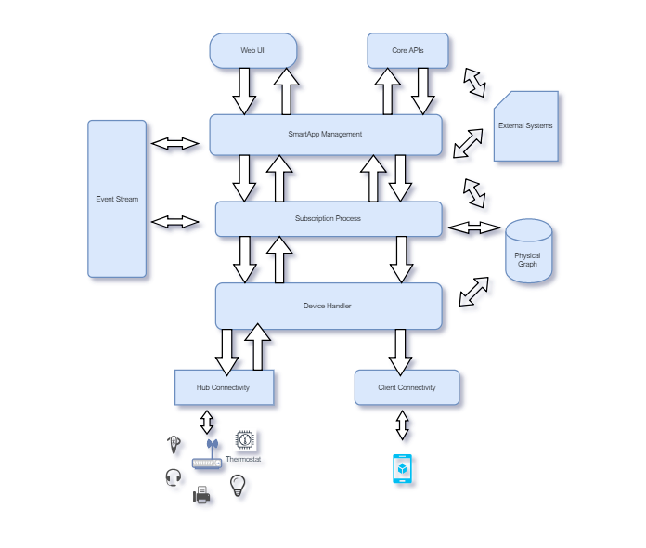

Figure 1 : Block Diagram [4]

* Connectivity management

The bottom layer which connects the devices to the SmartThings Hub is called as Connectivity management. There are two types of connections :

* Hub Connectivity : Connects Hub to the cloud.
* Client Connectivity : Connects client devices to the cloud.

This is a way to send or receive a command from the Internet.

* Device Handler execution

This layer is used to determine the type of device which is to be connected to the Hub. The Hub determines the device and then there are set of related commands which are specific to each of the device connected to it. A set of such messages is used to input to the Hub and there are SmartThings Events which act as the output for it.

* Subscription management

The device works on the architecture of Publish-Subscribe where the Events are the publish commands and the SmartApp have the subscriptions set up. This layer is used to relate the Events with appropriate SmartApp activity.

* SmartApp execution

This layer is used as the execution of tasks conducted due to the specific subscription or if there is any direct input to the SmartApp. The SmartApp then runs and stops after completing the entire task which was signalled by the events.

* Web UI

The topmost layer is called as the Web UI which controls all the other gadgets and monitor your devices, Hubs and many other aspects of your SmartThings system.

**Technical Details:**

**Model Number: STH-ETH-250**

**Physical:**

* Color: White
* Dimensions: 4.2" x 4.9" x 1.3"
* Weight: 7.68 oz
* Battery Type: 4 AA batteries

**Power:**

* In-wall power adapter (100-240VAC to 5VDC 2 A)
* 10 hours of backup power via four AA batteries [5]

**Communications:**

* ZigBee
* Z-Wave
* Bluetooth
* IP-accessible devices

**Compatible smart device brands:**

* Honeywell
* Philips Hue
* Kwikset IGN

**Certification**

* FCC/IC/CE

**Range (Ft.)**

* 50-130 ft

**Cost:**

* $ 100 (Amazon) [6]

**Security Concerns/Risks**

SmartThings Hub being a device which is connected to the internet and used for many of our daily life activities, the security offered for the Hub should be a top priority. A device with a low security can be catastrophic for its user as it contains data or permissions which might be used to deconstrue any activity.

The user can use the Hub for many purposes, ranging from lightning to door locks. Imagine what a hacker who can get into the device can do to the user. Given the amount of data which the hub offers, any vulnerability in the device can lead to unauthorized activities. He can easily disable the door locks which are controlled by the hub and rob the place. He can also have the sensors and alarms disabled which can disturb the home security system. Infact there have been many cases where the hub was hacked to monitor users and then used for burglary or ransom.

The security with the SmartThings Hub was not that highly secured as anyone with an OAuth token and the username and password can pair to the device and act as the original user. In a recent study conducted by CISCO Talos, researchers were able to identify about 20 flaws with the Hub which could have been used to dismantle the device and use it for illegitimate purposes. They were able to control the house by switching on and off appliances, changing the temperature from thermostats, spy on

user via the embedded camera and lock or unlock the doors. [7] They worked with Samsung to upgrade the security and helped them push a new firmware update which solves the flaws found in the study. They posted the study after Samsung had updated its system with the new firmware. The study was a insight on how much important security is when it is concerned with an IoT device.

**Concluding Comments**

A smart home is a connection between wireless communication, sensors, monitoring and tracking. It uses multiple technologies and applications to provide security and take control of the home easily.

Smart Home technology is projected to be a trillion-dollar business by 2025 and it represents the most advanced sector of the Internet of Things. We clearly have more information and  more control which helps us make better decisions and helps us optimize how we use our limited resources. The basic security loopholes discussed above are only a partial glimpse of the actual problem. Unless these issues are fixed with priority, smart homes might not be able to advance at the rate at which it is going right now.

**The Hub’s PCB :** [8]

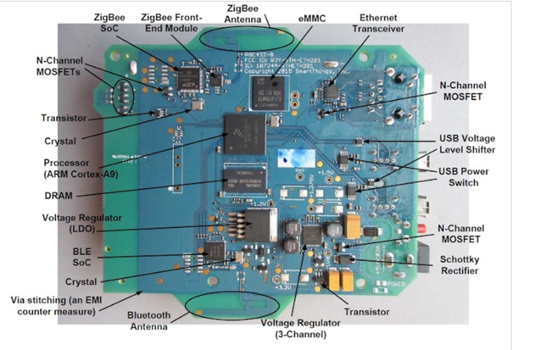

Figure 2 : Top view

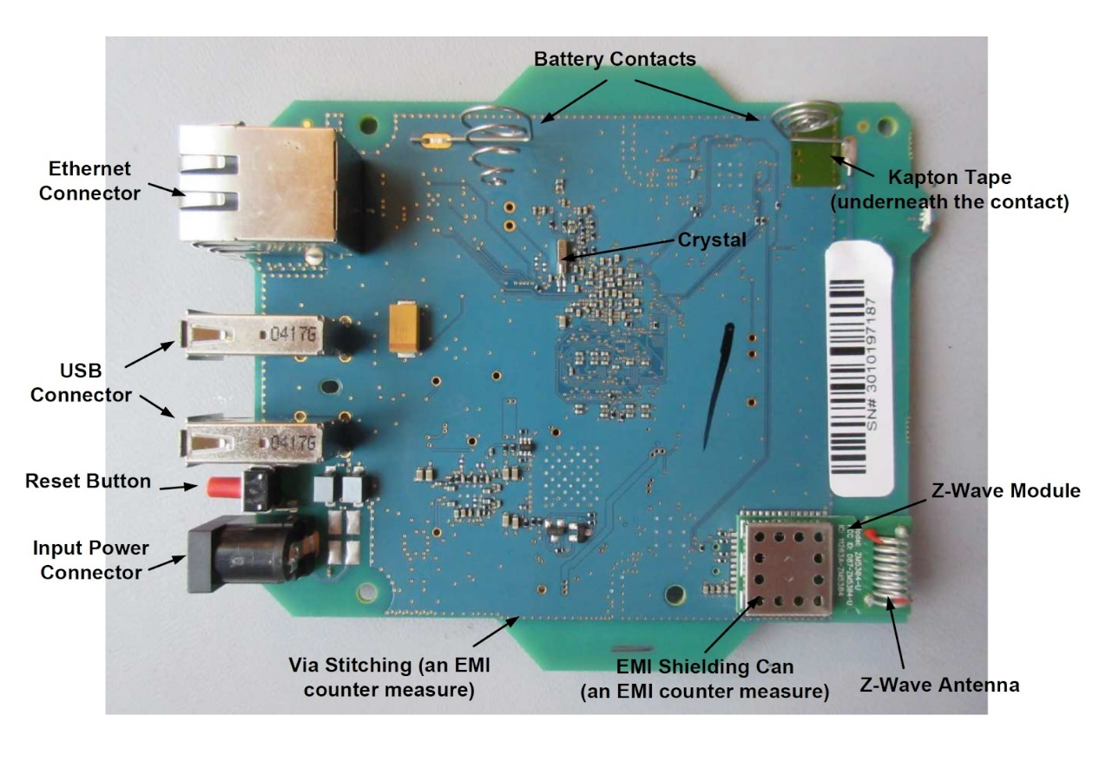

Figure 3 : Bottom view

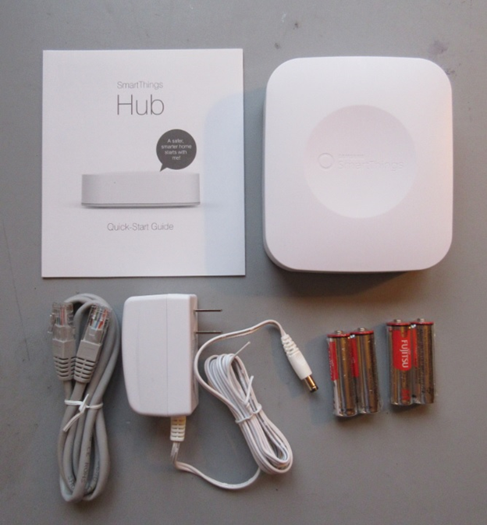

Figure 4 : SmartThings Smart Hub unboxing

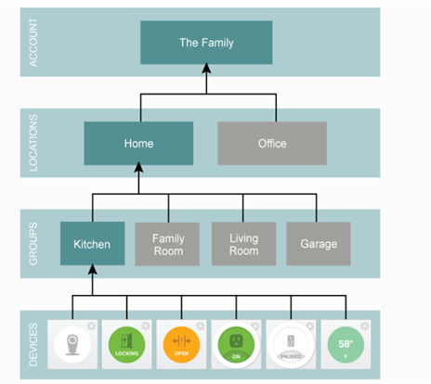

Figure 5: Publish-Subscribe Messaging Scheme

**References:**

[9] <https://www.pcmag.com/article/327457/what-is-a-smart-home-hub-and-do-you-need-one>

[10] <https://news.samsung.com/uk/samsung-announces-new-smartthings-hub-and-supporting-devices-to-open-up-the-connected-home>

[11]<https://support.smartthings.com/hc/en-us/articles/205956900-Meet-the-SmartThings-Hub-hardware>

[12] <https://internetofthingsagenda.techtarget.com/definition/smart-home-hub-home-automation-hub>

[13] <https://internetofbusiness.com/iot-security-vulnerabilities-samsung-smart-things-hub/>

[14] <https://www.information-age.com/samsungs-smartthings-hub-123473811/>